SIMATS ENGINEERING (SAVEETHA SCHOOL OF ENGINEERING)
Department of Computer Science and Engineering

ASSESSMENT TOOL 3 – DEBUGGING & OPTIMISATION TASK
Course Code: | CSA0604 | Course Title: | Design and Analysis of Algorithms
CO Assessed: | CO2 – Manipulation (BL1, BL2, BL3) | Assessment: | Assessment Tool 3 – Debugging &  Optimisation Task
Weightage: | 10% of CIA | Total Marks: | 100
CO2 Statement: | Apply Brute Force technique to solve sorting, searching, Closest-Pair and Convex-Hull problems  (BL1, BL2, BL3)
Student Name: | ANGEL DEEPIKA M | Reg. No.: | 192521272
Section / Batch: | B tech IT | Date: | 23-07-26

Instructions to Students
- Answer ALL debugging and optimisation tasks. Total Marks: 100.
- Carefully analyze the given program/code segment before identifying errors.
- Clearly identify logical, syntactical, and performance-related issues in the code.
- Apply systematic debugging techniques to correct the errors effectively.
- Optimize the given solution by improving efficiency, reducing unnecessary computations, or enhancing time complexity wherever possible.
- Provide proper justification for all corrections and optimization decisions.
- Write clean, structured, and well-documented code with appropriate comments.
- Maintain clarity, logical reasoning, and technical accuracy throughout the solution.

Question Type | Focus Area | Questions | Marks
Debugging & Optimisation Task | Identify errors, debug programs, and optimize algorithm efficiency using appropriate techniques | Q1 - Q2 | 100 (2 × 50)
 | GRAND TOTAL: | 100 Marks

SECTION A – DEBUGGING & OPTIMISATION TASK
Q1. Debugging Bubble Sort Code (Adjacent Comparison Uses Wrong Index Pair)
The following Bubble Sort implementation compares non-adjacent elements due to an incorrect index reference inside the inner loop, which breaks the fundamental logic of repeated neighboring swaps. Carefully inspect the comparison and swapping statements and explain why local inversions are not resolved correctly. Debug the code step-by-step so that only adjacent elements are compared and exchanged. Optimize the corrected version using a swap flag to reduce unnecessary passes. Analyze the algorithm in best, average, and worst cases and rewrite the final code with proper comments.
def bubble_sort(arr):
n = len(arr)
for i in range(n):
for j in range(0, n-i-1):
if arr[j] > arr[i]: # ERROR
arr[j], arr[i] = arr[i], arr[j]

return arr
Q2. Debugging Binary Search (Infinite Loop Issue)
The Binary Search code below leads to an infinite loop for some inputs. Identify the logical errors in updating search boundaries. Explain why the loop fails to terminate. Debug the algorithm to correctly adjust low and high indices. Optimize mid calculation if necessary. Analyze complexity and rewrite the corrected version.
def binary_search(arr, key):
low, high = 0, len(arr)-1
while low <= high:
mid = (low + high)//2
if arr[mid] == key:
return mid
elif arr[mid] < key:
low = mid # ERROR
else:
high = mid # ERROR
Code of Conduct
I __________________________ (Name / Reg No) certify that this submission is my original work and that I have adhered to the guidelines specified for this assessment. I understand that any violation of academic integrity rules will result in disciplinary action.
Signature of the Student: _________________________

RUBRICS FOR CALCULATION
Criteria | Wt. | Level 4 – Exemplary | Level 3 –  Proficient | Level 2 –  Developing | Level 1 –  Beginning
Problem  Identification | 20% | Accurately identifies all errors and root causes with clear understanding | Identifies most errors with minor gaps | Identifies some errors but misses key issues | Unable to identify errors correctly
Debugging | 25% | Applies systematic debugging techniques effectively to resolve issues | Uses appropriate debugging methods with minor errors | Limited debugging approach; requires guidance | Unable to debug or resolve issues
Optimization | 20% | Optimizes code by significantly improving time complexity using efficient algorithms | Improves time complexity with minor gaps in efficiency | Limited improvement in time complexity | No improvement;  inefficient approach retained
Analysis | 20% | Demonstrates strong logical reasoning and clear justification of solutions | Shows reasonable  analysis with some justification | Limited analysis; weak reasoning | No analytical reasoning demonstrated
Code Quality | 15% | Produces clean, well-structured code with proper comments and documentation | Code is mostly clear with minor documentation gaps | Code lacks structure and proper documentation | Poorly written code with no documentation

Marks Evaluation:
Question No. | Problem  Identification  (20%) | Debugging (25%) | Optimization (20%) | Analysis (20%) | Code Quality (15%) | Total Marks (Each – 50)
Q1 | 4 | 3 | 3 | 2 | 4 | 39
Q2 | 4 | 4 | 4 | 3 | 2 | 44
 |  |  |  | Overall Total (100) |  | 83

Faculty In-charge | Course Coordinator | Head of Department
Signature: _______________ | Signature: _______________ | Signature: _______________
Date: ___________________ | Date: ___________________ | Date: ___________________

Q1. Debugging Bubble Sort Code (Adjacent Comparison Uses Wrong Index Pair)

- Identify the Logical Error
The error is:
if arr[j] > arr[i]:
arr[j], arr[i] = arr[i], arr[j]
Bubble Sort should compare adjacent elements (arr[j] and arr[j+1]), not arr[j] and arr[i].
The correct statements are:
if arr[j] > arr[j+1]:
arr[j], arr[j+1] = arr[j+1], arr[j]

b) Why Local Inversions Are Not Resolved
- Bubble Sort removes inversions by swapping neighboring elements.
- Using arr[i] compares elements that are far apart.
- Since adjacent elements are not compared correctly, the largest element does not move to its correct position after each pass, so the array may remain unsorted.

c) Optimization Using Swap Flag
A swap flag is used to check whether any swapping occurred during a pass.
- If no swaps occur, the array is already sorted.
- The algorithm stops early, avoiding unnecessary passes.

d) Time Complexity
- Best Case: O(n) (already sorted; no swaps, one pass only)
- Average Case: O(n²)
- Worst Case: O(n²) (reverse sorted array)
Space Complexity: O (1)

Correct Python Code

def bubble_sort(arr):
n = len(arr)

# Traverse the array
for i in range(n):
swapped = Fals
for j in range(0, n - i - 1):
if arr[j] > arr[j + 1]:
# Swap adjacent elements
arr[j], arr[j + 1] = arr [j + 1], arr[j]
swapped = True

if not swapped:
break

return arr

arr = [64, 34, 25, 12, 22]

print ("Original Array:", arr)

bubble_sort(arr)

print ("Sorted Array:", arr)

Sample Output
Original Array: [64, 34, 25, 12, 22]
Sorted Array: [12, 22, 25, 34, 64]

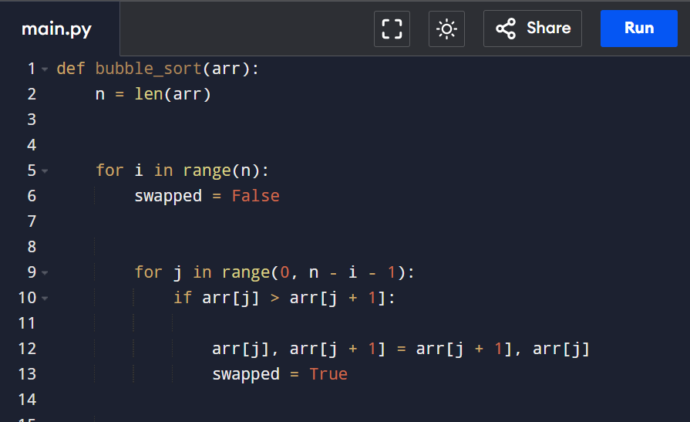

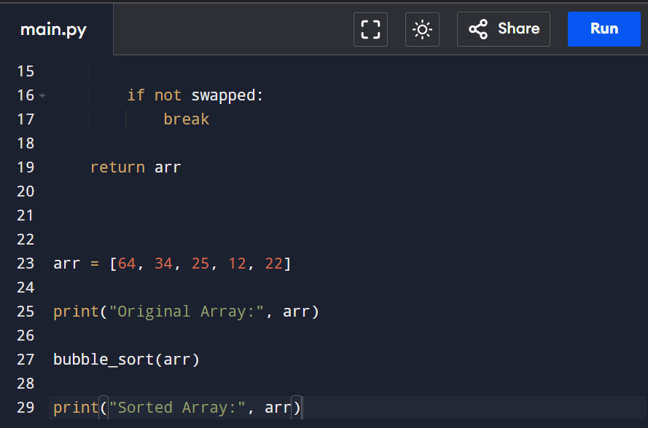

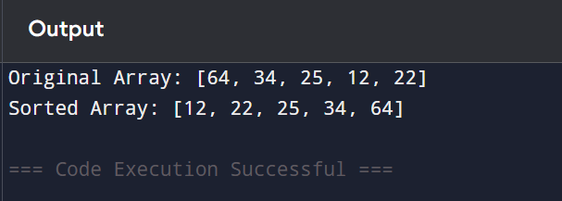

Verification
- The comparison was corrected from arr[j] > arr[i] to arr[j] > arr[j+1].
- Only adjacent elements are compared and swapped in each pass.
- The swap flag stops the algorithm early when the array becomes sorted.
- The program correctly sorts the array in ascending order.

Result
The incorrect comparison and swapping logic were fixed by using adjacent elements. The optimized Bubble Sort correctly resolves local inversions, reduces unnecessary passes using a swap flag, and sorts the array successfully. The algorithm has O(n) best-case time complexity and O(n²) average and worst-case time complexity with O(1) space complexity.

Q2. Debugging Binary Search (Infinite Loop Issue)

a) Identify the Logical Errors
The errors are:
low = mid
high = mid
When the key is not found, low or high may remain unchanged, causing the same mid value to be calculated repeatedly. This results in an infinite loop.
The correct updates are:
low = mid + 1
high = mid - 1

b) Why the Loop Fails to Terminate
- If arr[mid] < key, the search should continue after mid, so low must become mid + 1.
- If arr[mid] > key, the search should continue before mid, so high must become mid - 1.
- Updating to mid instead of mid ± 1 does not reduce the search range, so the loop may never end.

c) Optimized Mid Calculation
To avoid overflow in some programming languages, calculate mid as:
mid = low + (high - low) // 2
(In Python, both formulas work correctly, but this version is considered a best practice.)

d) Time Complexity
- Best Case: O (1) (key found at first comparison)
- Average Case: O (log n)
- Worst Case: O (log n)
- Space Complexity: O (1)

Correct Python Code

def binary search(arr, key):
low = 0
high = len(arr) - 1

while low <= high:
mid = low + (high - low) // 2

if arr[mid] == key:
return mid
elif arr[mid] < key:
low = mid + 1
else:
high = mid - 1

return -1

arr = [10, 20, 30, 40, 50, 60, 70]
key = int (input("Enter the element to search: "))

result = binary search (arr, key)

if result! = -1:
print ("Element found at index", result)
else:
print ("Element not found")

Sample Input
Enter the element to search: 50

Output
Element found at index 4

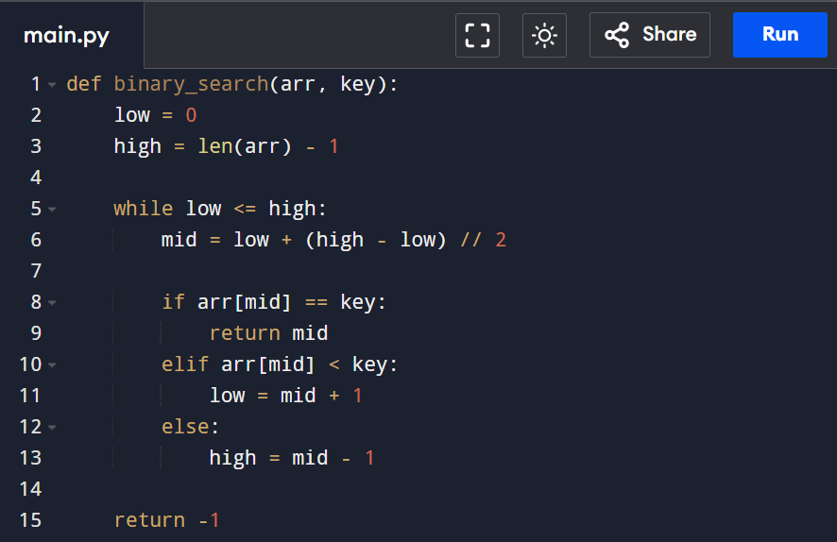

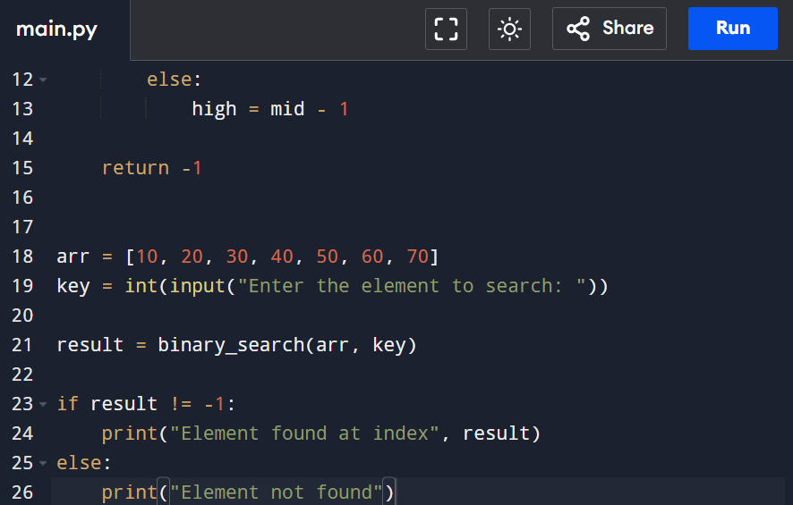

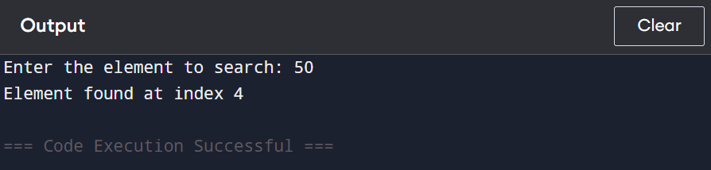

Verification
- The search boundaries are correctly updated using low = mid + 1 and high = mid - 1.
- The search range decreases in every iteration, preventing an infinite loop.
- The optimized mid calculation mid = low + (high - low) // 2 correctly identifies the middle element.
- The program successfully returns the index of the searched element or -1 if it is not found.

Result
The logical errors in updating the search boundaries were corrected. The binary search algorithm now terminates correctly, avoids infinite loops, and searches efficiently with O (log n) time complexity and O(1) space complexity.

